**Assignment**

**Learner Details**

* **Name: Nikhil k**
* **Enrollment Number: SU625MR004**
* **Batch / Class: June 2025 MERN**
* **Assignment: Photo Album Project**
* **Date of Submission: 10/07/2025**

**Problem Solving Activity**

**1. Program Statement**

Create a photo album website containing 20 images displayed on the homepage in a grid layout. Each image links to a separate detail page showing a larger version of the image with its title and description, and an option to navigate back to the main album.

**2. Algorithm**

1. Create the homepage (index.html) with a header and a main container for images.
2. Add 20 images inside anchor (<a>) tags that link to their respective detail pages.
3. For each detail page:
   * Display the image title in <h1>.
   * Show the image in larger size.
   * Include a short descriptive paragraph.
   * Provide a "Back to Album" link to return to the main page.
4. Link CSS files to style the layout and maintain consistency.

**3. Pseudocode**

START

CREATE main page with header "My Photo Album"

FOR each image from 1 to 20

ADD <a> tag linking to its detail page

INSERT <img> inside the <a>

END FOR

FOR each image detail page

DISPLAY title and image

DISPLAY description

ADD "Back to Album" link

END FOR

END

**4. Program Code**

<!DOCTYPE html>

<html lang="en">

<head>

<meta charset="UTF-8">

<meta name="viewport" content="width=device-width, initial-scale=1.0">

<title>My Photo Album</title>

<link rel="stylesheet" href="style.css">

</head>

<body>

<header>

<h1>My Photo Album</h1>

</header>

<main class="album">

<a href="pages/photo1.html"><img src="images/photo1.jpg" alt="Photo 1"></a>

<a href="pages/photo2.html"><img src="images/photo2.jpg" alt="Photo 2"></a>

<a href="pages/photo3.html"><img src="images/photo3.jpg" alt="Photo 3"></a>

<a href="pages/photo4.html"><img src="images/photo4.jpg" alt="Photo 4"></a>

<a href="pages/photo5.html"><img src="images/photo5.jpg" alt="Photo 5"></a>

<a href="pages/photo6.html"><img src="images/photo6.jpg" alt="Photo 6"></a>

<a href="pages/photo7.html"><img src="images/photo7.jpg" alt="Photo 7"></a>

<a href="pages/photo8.html"><img src="images/photo8.jpg" alt="Photo 8"></a>

<a href="pages/photo9.html"><img src="images/photo9.jpg" alt="Photo 9"></a>

<a href="pages/photo10.html"><img src="images/photo10.jpg" alt="Photo 10"></a>

<a href="pages/photo11.html"><img src="images/photo11.jpg" alt="Photo 11"></a>

<a href="pages/photo12.html"><img src="images/photo12.jpg" alt="Photo 12"></a>

<a href="pages/photo13.html"><img src="images/photo13.jpg" alt="Photo 13"></a>

<a href="pages/photo14.html"><img src="images/photo14.jpg" alt="Photo 14"></a>

<a href="pages/photo15.html"><img src="images/photo15.jpg" alt="Photo 15"></a>

<a href="pages/photo16.html"><img src="images/photo16.jpg" alt="Photo 16"></a>

<a href="pages/photo17.html"><img src="images/photo17.jpg" alt="Photo 17"></a>

<a href="pages/photo18.html"><img src="images/photo18.jpg" alt="Photo 18"></a>

<a href="pages/photo19.html"><img src="images/photo19.jpg" alt="Photo 19"></a>

<a href="pages/photo20.html"><img src="images/photo20.jpg" alt="Photo 20"></a>

</main>

</body>

</html>

<!DOCTYPE html>

<html lang="en">

<head>

<meta charset="UTF-8" />

<meta name="viewport" content="width=device-width, initial-scale=1.0"/>

<title>Photo 1</title>

<link rel="stylesheet" href="../pages/photo.css" />

</head>

<body>

<div class="container">

<h1>Photo 1: Abstract Flow</h1>

<img src="../images/photo1.jpg" alt="Photo 1" />

<div class="description">

<p>A stunning abstract painting with vivid swirls of blue, orange, and yellow evoking motion and emotion.</p>

</div>

<a href="../index.html" class="back-btn">← Back to Album</a>

</div>

</body>

</html>

**5. Test Cases**

| **Action** | **Expected Result** |
| --- | --- |
| Click on an image on homepage | Opens the corresponding detail page |
| Click "Back to Album" | Returns to the homepage |
| Image missing in folder | Displays alt text instead of the image |
| Resize browser | Images rearrange or scale based on CSS responsiveness |

**6. Screenshots of Output**

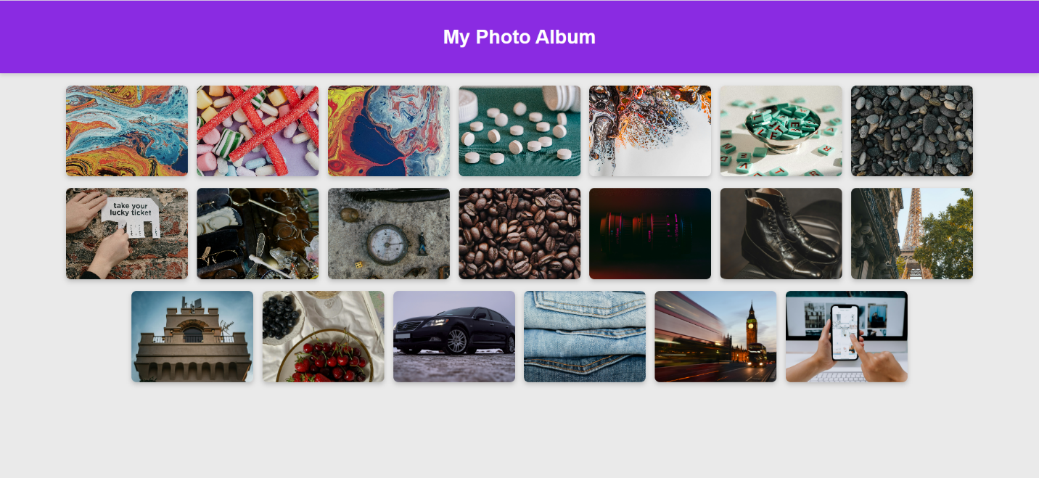

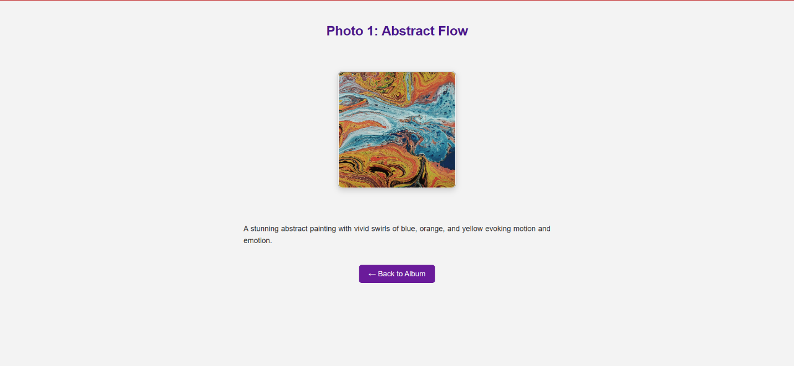

**7. Observation / Reflection**

• I learned how to link multiple HTML pages together for navigation.

• Creating individual detail pages for each image improved my understanding of page structuring.

• Using a consistent layout and style across pages made the project look more professional.